Setting Up a Security Group

A security group acts as a virtual firewall that controls the traffic for one or more instances. When we launch an instance, we associate one or more security groups with the instance. We add rules to each security group that allow traffic to or from its associated instances.

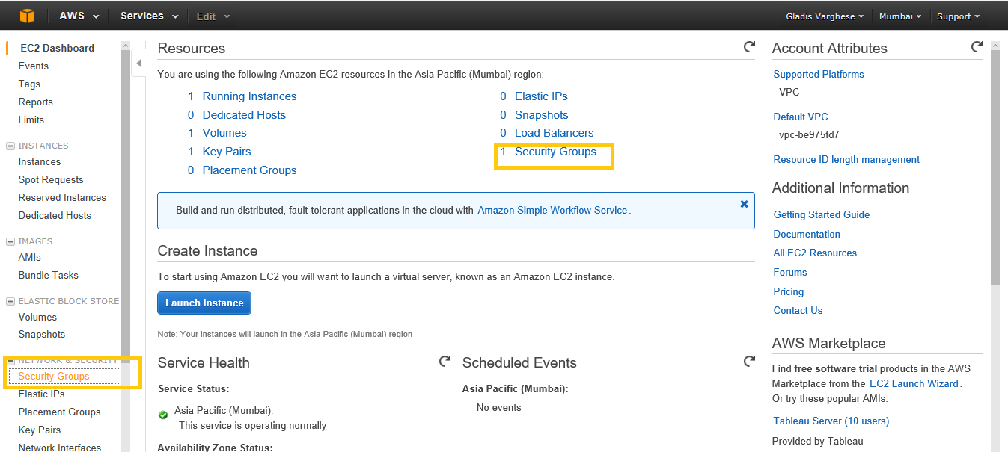

Step2: Choose Create Security Group.

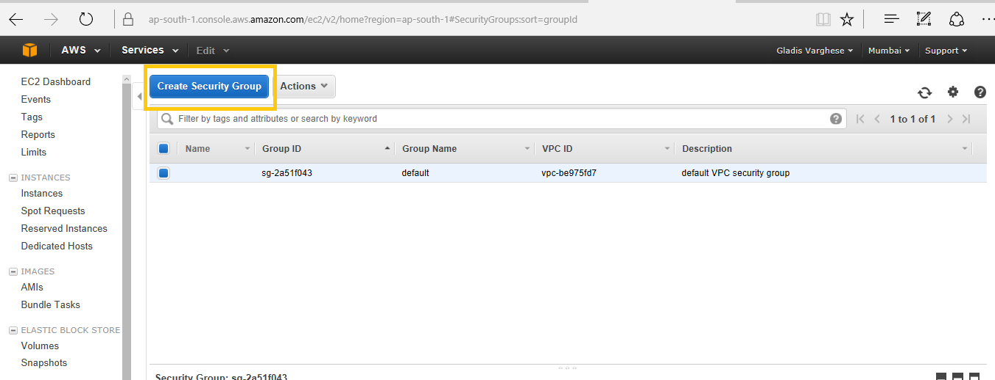

Step3: Specify a name and description for the security group. We can add rules, or we can choose Create to create the security group now (we can always add rules later).

Following rules are added here for inbound:

We can allow web servers to receive all inbound HTTP and HTTPS traffic. On the Inbound tab, choose Edit. In the dialog, choose Add Rule.

Select HTTP from the type list and make sure that source is set to Anywhere (0.0.0.0/0).

Add a similar rule for the HTTPS protocol.

Select HTTPS from the type list and make sure that source is set to Anywhere (0.0.0.0/0).

To connect to a Linux instance, we need to allow SSH traffic. Choose Add Rule, and then select SSH from the Type list.

Select SSH from the type list. In the source box ensure custom is selected and specify public address of our computer or network in CIDR notation.

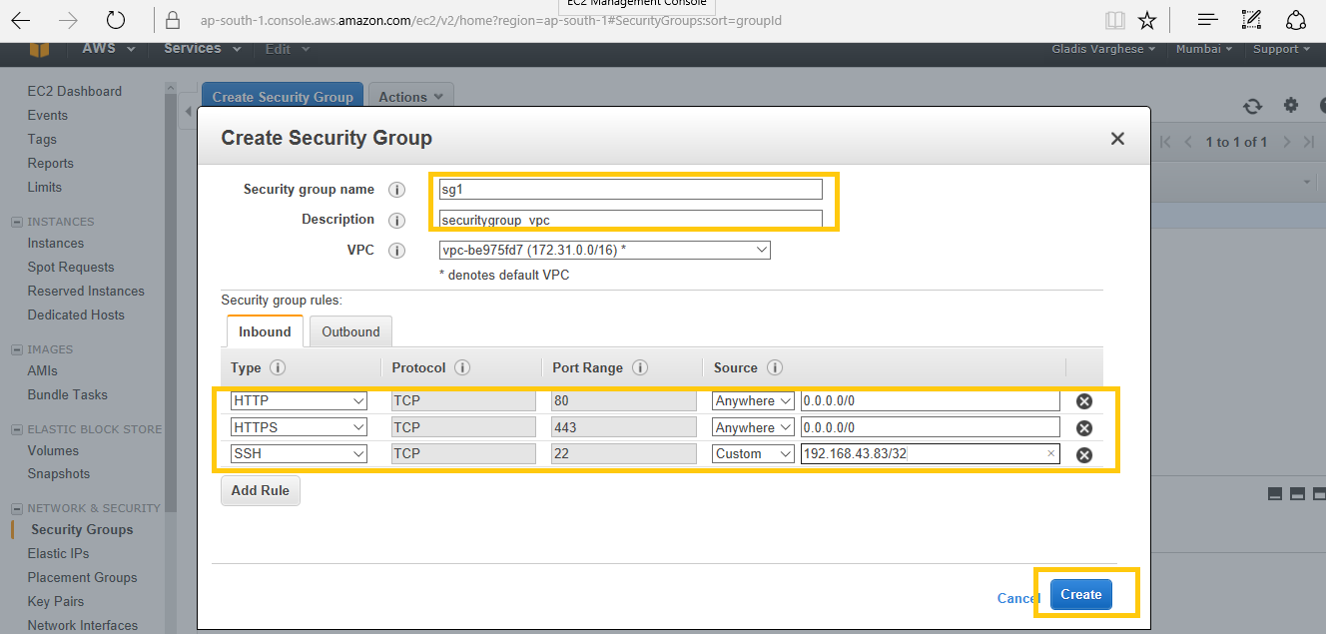

The security group is created:

